http://bromsgrovewelcomesrefugees.uk
24 May 2016

Dear supporters,

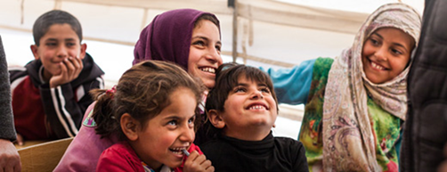
Good news! At the end of June, the first few families will be arriving in Worcestershire to be resettled in Redditch and Kidderminster.

The UK has pledged to accept 4,000 refugees a year for the next five years. The majority of refugees will arrive from the camps bordering Syria.
The Government have committed for resettlement costs from its foreign aid budget for a period of 5 years for every refugee.
This government has allocated money, other than an allowance for daily living expenses, which is aimed at supporting accommodation, funding school places for children and access to medical and mental health services.
So why do we need to raise additional money?
The District Councils within the Worcestershire county have plans to resettle up to 50 refugees during 2016.
The funds pledged by you to “Bromsgrove and Redditch Welcomes Refugees” will add to the Government provision by helping to meet for those as yet unforeseen costs, things like funding driving lessons, broadband, laptop, TV, training courses to help them meet UK requirements or everyday things we take for granted; clothes, furniture and toys for the children. The refugees arriving in the UK will have the right to work status from day one.

Who are Bromsgrove and Redditch Welcomes Refugees?
“Bromsgrove and Redditch Welcomes Refugees” is a small group of local people of all religious and non-religious denominations, political persuasions and of different ethnic and cultural backgrounds. We all have been moved by the enormity of the global humanitarian crisis which we have seen this century, and we want to assist the families get the best support and help in order to settle and integrate into their new local communities.
The passionate and caring communities of Bromsgrove and Redditch have already sent over 700 bags full of clothing, footwear, tents, summer wear, dignity packs, mosquito repellents etc. to the camps in Jordan, Lesbos, Calais and Dunkirk.
By making a pledge to “Bromsgrove and Redditch Welcomes Refugees”, you are supporting refugee families, regardless where they settle within Worcestershire, to assist them to recover from the worst of their traumas, offer them friendship and provide practical support to enable them to rebuild their lives destroyed by the war.

The extent of the crisis

As I’m sure you have witnessed, the Syrian refugee crisis is a humanitarian catastrophe of historic proportions, since 2011 half the Syrian population - 11 million people - have been displaced. This is the largest humanitarian crisis since World War 2.

More than 80% of Syrian children have been affected by the brutal war. 7.5 million Syrian children, inside and outside the country, are in need of humanitarian aid. 2.6 million children are no longer in school and 2 million are living as refugees in neighboring countries or on the run in search of safety. Unicef

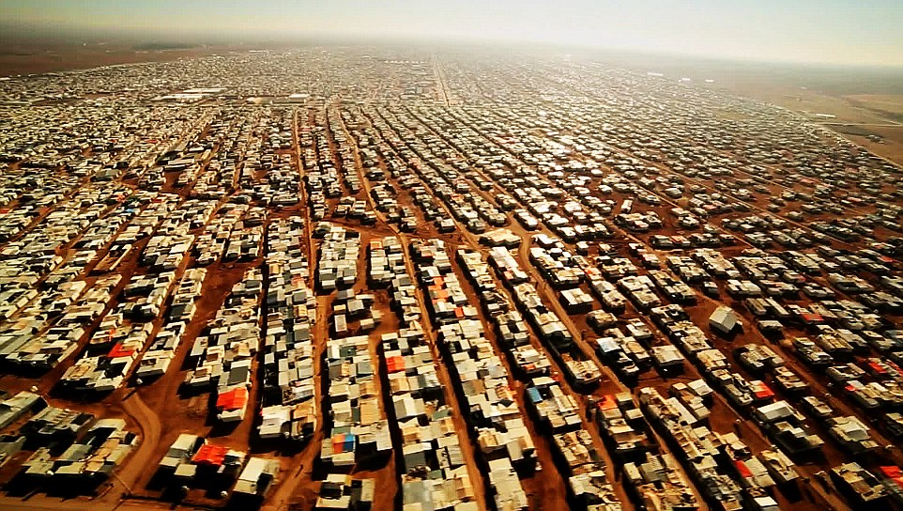
One of the four camps in Jordan hosting 85,000 refugees

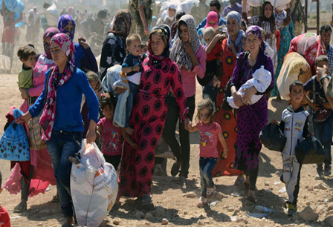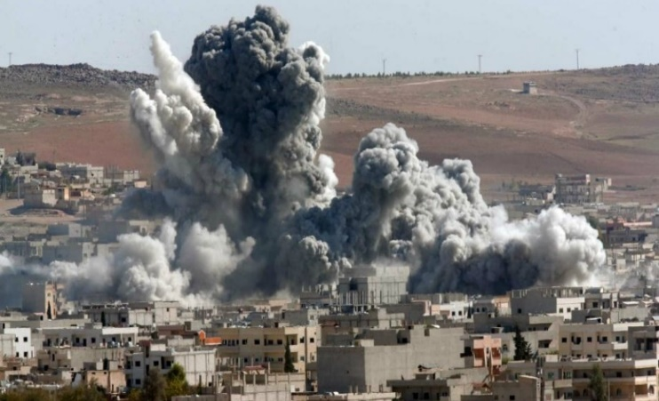

These refugees are in search of stability and peace as their country has dissolved into chaos and violence, and overwhelming numbers are children, women, families — themselves victims of terrorism.

How can you help?

With your help we can support these families meaningfully as they move to live among us locally.

We suggest that you may like to help by making a pledge to Bromsgrove and Redditch Welcome Refugees. This would offer support to refugee families to help them resettle locally, and to recover from the worst of their traumas, offer them friendship and provide practical support. These acts of kindness will enable them to rebuild their lives, which have been cruelly destroyed by the civil war.

Please help us at this stage by pledging a financial donation to be given once the first families arrive and we have assessed how best to help them. We will tell you when we have done this and give you details of the sorts of items on which we will be spending your donation on and then will collect your pledge.
Please fill in the attached form and pledge generously. Thank you so much in advance very much for your support.
If you have any questions or comments about your pledge to Bromsgrove and Redditch Welcome Refugees then please call or email me on:
naeemarif57@gmail.com
Mobile number: 07722429304
Yours sincerely,
Naeem
Naeem Arif

Vice Chairman
Bromsgrove and Redditch Welcome Refugees Group

Note: Redditch has formally joined Bromsgrove to form one ‘welcome’ group. Hence the name ‘Bromsgrove and Redditch Welcome Refugees’.

My Pledge

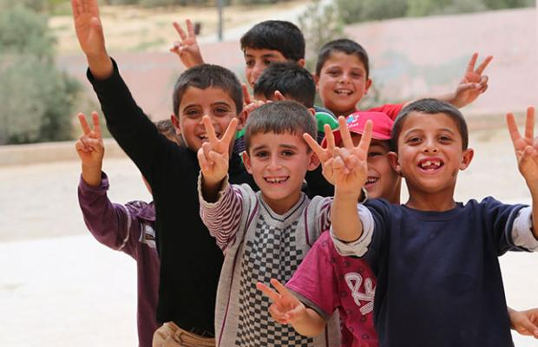

I (name)----------------------------------------- pledge to pay the amount of £--------

as a single gift or a monthly donation of £--------

I will pay this by credit card or cheque made payable to “Bromsgrove Welcomes Refugees” to support their work resettling Refugees anywhere in Worcestershire county.

My address is: __________________________________________________________

______________________________________________________________________

My email address is:

My phone number is:
______________________________________________________________________

Signed…………………………………………………………………

Dated………………………………………………………………………

Please scan and email your Pledged form today to naeemarif57@gmail.com or send by post to:
Naeem Arif, 13 Dawson Road, Bromsgrove, B61 7JF
THANK YOU

