Update on Bromsgrove and Redditch Welcomes Refugees BRWR,
previously Bromsgrove Welcomes Refugees BWR.

Following an inaugural Open meeting at St. Stephen’s church on May 24th, Bromsgrove Welcomes Refugees has now become Bromsgrove and Redditch Welcomes Refugees and we have over 400 volunteers on our mailing list. At the Open meeting in Redditch, Abdul Nasser was interviewed as a one of the first Syrian refugees now living here with his wife and family. See press reports:
http://www.redditchadvertiser.co.uk/news/local/14520987._Redditch_will_be_a_welcoming_town__when_it_greets_Syrian_refugees/
http://redditchstandard.co.uk/news/hundreds-attend-refugee-support-meeting-redditch/
Recently we held a training day for volunteers, called ‘Getting Ready’ at St Andrews Church in Barnt Green. We heard from an Eritrean refugee who had come from the Calais camp, granted asylum because of his Christian faith for which he was under threat in Eritrea. Joseph is now training to be an accountant here and has just become Treasurer of BRWR.
Professor Jenny Phillimore a researcher from Birmingham University then spoke on Integrating Refugees.
Derek Allen, the Strategic Housing Manager for Bromsgrove and Redditch Districts, took part in a panel discussion with Julie Kashirahamwe from Refugee Action which has been selected as the preferred provider to deliver a Refugee Integration and Independence Service for Worcestershire. The service will support all adults, young people and children accepted by Worcestershire's local authorities under the Syrian Vulnerable Person Resettlement (VPR) scheme.
The contract will commence at the beginning of June with the first cohort of refugees scheduled to arrive at the end of June. The first 3 families (comprising 8 refugees) will be resettled in Redditch. Two families are linked and will be resettled in the same property.

Hopefully the Home Office will arrange for a further 4 families to arrive in mid-July who will be resettled in 2 properties in Kidderminster and a further 2 properties in Redditch.

Private sector landlords are being approached in other districts to resettle further families later this year to meet the County Council’s commitment to resettle 50 Syrian refugees in 2016. We are hopeful that some will be coming to Bromsgrove in September or October.

The resettlement scheme is funded from the Foreign Aid budget: the Vulnerable Persons Resettlement Scheme which is ring-fenced and cannot be spent elsewhere. Further resources will be invested into the local NHS and Education by the Government. These additional resources will help to ensure that any impact on services for local residents will be minimised.

All the refugees will have had stringent bio-security checks on them. They will be flown in by the Red Cross on charter flights and met at the airport, provided with food, and settled in to their new homes. It is likely they will suffer from culture shock and must be left to settle in with intensive support from Refugee Action.

We volunteers will be directed by the YSS who are mapping what voluntary sector exists in which areas and what potential exists for those organisations to support refugees. It is likely that we shall be called on later rather than in the first couple of weeks, helped to develop our services to provide such things such as extra English language practice, employment related support and, most importantly, befriending activities. There will be a strong emphasis on empowerment and letting the Syrians make their own decisions, rather than hand-holding and making phone calls for them for example. Learning the language will be a priority.

Anu Shukla the Standard Reporter, showed us the film she made in February in the Calais ‘jungle’ which is available on U-tube.

We ran workshops in the afternoon and these were on fund raising, befriending and communication. We are available to give talks and presentations to local organisations (so do ask us) and three of us went into St Johns Middle School to talk about refugees for their RE Enrichment day, yesterday Wednesday June 8th, under the title of ‘Who is my Neighbour?’ We have an excellent power point presentation.

Please watch the new website, BRWR.uk, and the press for further developments and details about activities. We have a fund raising dinner in Redditch coming up on July 9th at the Town Hall - tickets will be £15. Tickets available from:
Tasnim Khawaja tasnimkhawaja@outlook.com
Sue Yeng sueyeng@hotmail.co.uk
Sally Woodget markwoodget@yahoo.co.uk
During Refugee week, which is from June 20th to 26th , we are encouraged to hold coffee mornings, or other fund raising events.

There is a new Pledge Scheme taking off – please see the website.
http://brwr.uk/wp-content/uploads/2016/05/BRWR-Pledge.docx

Clothing collections for Calais and Dunkirk continue with a white van taking them to the sorting place in Malvern, before abroad. We collected over 900 bags full in the 3 earlier collections from St. John’s Church car park. The future collections will be from St Luke’s church in Redditch and the Central Mosque. The next being on June 18th from 2-5pm – details again on the website. Further collections are arranged for 23rd July and 27th August.

We also continue with our Arabic classes at St. John’s Church hall on Tuesday evenings.

Refugee Action have advertised for different paid and voluntary roles. The details are as below. I apologise some are past closing date.

Thank you for signing up to Refugee Action's job alerts, we currently have the following vacancies:

Business Development Manager (West Midlands)
Hours: 17.5 per week
Location: Birmingham
Closing Date: 12th June 2016 - 11.59pm
Interview Date: 28th June 2016

West Midlands Regional Resettlement Manager
Location: Birmingham
Closing Date: 13th June 2016- 11.59pm
Interview Date: 29th June 2016

Resettlement Manager
Location: Worcester
Closing Date: 5th June 2016- 11.59pm
Interview Date: 16th June 2016

Resettlement Workers x2
Location: Worcester
Closing Date: 5th June 2016- 11.59pm
Interview Date: 14th & 15th June 2016

Project Manager - Street Legal
Location: London
Closing Date: 10th June 2016- 4.00pm
Interview Date: 16th or 17th June 2016

Please also look at the pdf titled Worcestershire resettlement volunteer roles

John Cochrane 8th June 2016

Bromsgrove and Redditch Welcomes Refugees held first meeting
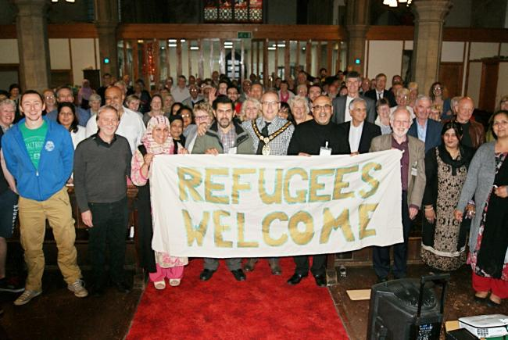
Bromsgrove and Redditch Welcomes Refugees, a community group preparing to welcome and support Syrian refugees
27 May 2016 / Ben Russell
Share: 3 comments

Don't be last to know! Get the latest local news straight to your inbox.
Sign up

"REDDITCH will be a welcoming town," that's the message after the first meeting of a new group started to help greet Syrian refugees to Redditch.
Bromsgrove and Redditch Welcomes Refugees is a community group of people preparing to welcome and support Syrian refugees when the first families arrive.
The group, which held its first meeting last week, is seeking volunteers to help give furniture, clothes, essential supplies, translation services and most importantly, it says, friendship.
The meeting, at St Stephen's Church in Redditch, saw more than 130 people of all faiths, cultures and politics turn up.
A spokesman for Bromsgrove and Redditch Welcomes Refugees said: "The meeting was very positive and went very well.
"All those attending were fully involved and attentive to all that was said."
During the meeting there was a moving account from Abdul Nasser, who with his wife and daughter, was one of the first refugees brought here from Syria by the British Government.
He expressed gratitude to the British Government and described how his own parents as well as his wife's parents had been brutally killed.
It was followed by a lively question and answer session.
Following the meeting Bromsgrove and Redditch Welcome Refugees will be running a training day for those who want to be involved in some way in welcoming them.
The Getting Ready training day will be held at St Andrew’s Parish Centre, 24 Sandhills Road, Barnt Green from 10am to 4pm on Saturday, June 4.
It offers an opportunity to meet Julie Kashirahamwe, national resettlement manager of Refugee Action.
The Advertiser reported last week that Redditch will be the first town in the county to take in Syrian Refugees.
The first three families (comprising eight refugees) will be resettled in town at the end of June.
Two families are linked and will be put in the same property.
Worcestershire County Council is liaising with the Home Office to arrange for a further four families to arrive in mid-July who will be resettled in a further two homes in Redditch and two in Kidderminster.
For more information about Bromsgrove and Redditch Welcomes Refugees or to book a place for the training day, email janeteking110@gmail.com or call 0121 4452802.

Hundreds attend refugee support meeting in Redditch
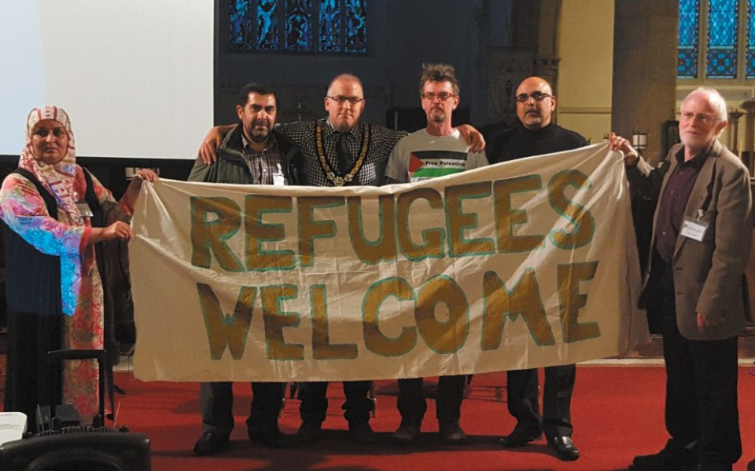

Written byAnu Shukla
Published3:00 pm, May 27, 2016

UPDATED: 4:09 pm, May 26, 2016

31 shares
0 Comments
ALMOST 200 people gathered at St Stephen’s Church on Tuesday when the Bromsgrove and Redditch Welcomes Refugees Committee hosted a public meeting about helping new arrivals, writes Anu Shukla.
Mayor of Redditch Coun Joe Baker made a profound opening speech.
He later told the Standard: “Sometimes we must look outside our own cocoon, open our hearts to humanity and think – if it was me, my mother or my child, I hope and pray someone will offer their hand of help and friendship to me too.”
He added: “People react to kindness and when they are shown it, they will do the same. We build strength through compassion.”
Coun Baker said the meeting was important to emphasise to residents the refugees will be settled in the town without costing the tax payer.
BWR founding member Dr John Cochrane said: “All of humanity is one family and it is our duty, our privilege, to help all in need.” Dr Cochrane then welcomed Syrian survivor, Abdul Nasser – one of the first refugees to arrive in the UK with his daughter.
With the aid of a translator, Abdul shared his tragic story with the audience.
He said his parents were killed in Syria and he does not know where the rest of his family are.
Members of the audience interacted with Abdul and told him he was welcome.
Standard reporter Anu Shukla also delivered a presentation about her experience at the refugee camps in Calais and Dunkirk, highlighting the massive effort of British volunteers in France.
BRWR vice chairman Naeem Arif later gave an emotional speech about the suffering of child refugees in Syria before presenting a film which documented their survival amidst the debri of bombs.
Several local residents later approached reporter Anu Shukla to express their inspiration to volunteer at the French camps.

