



**June 20** is the **United Nations' (UN) World Refugee Day**. There are millions of refugees; Women, men and children who have been forced to flee their homes and countries by the atrocities of war and abuse of their human rights. In doing so they have suffered un-measurable hardship. For the sake of their humanity and ours we have to support them. Please help observe this day and raise funds for refugees.

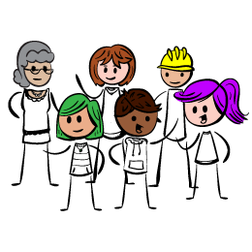

Can you help by organizing a coffee morning

to raise funds for refugees coming to our area?

**Invite** your friends, have a coffee, make time to chat, while raising some funds for refugees. These funds will help them to **settle,** make their life more comfortable and they'll feel more welcome. Refugees will need things like Books, Toys, furniture etc Fundraising help Share the cost of the coffee morning. Hold it with a friend. Ask for donations Have extra activities: -a raffle,a bake off, play a game, a quiz, have a jumble sale, book or clothes swap.

Plan the Day-

Choose to hold it:

- in Refugee week which is 20th-26th June 2016

or a date to suit you.

- at home, at work, in a church hall or community centre.

Provide alternatives to tea and coffee.

Ask for helpers to assist with the set up, serving provisions or baking.

Safety first

-Ensure friends are present if there are any unknown people coming.

-Maintain good hygiene. -Label food, some ingredients cause allergy -See Food Standards Agency website for guidance on selling food.

<https://www.food.gov.uk/business-industry/caterers/food-hygiene/charity-community-groups>

Afterwards

Thank your helpers

As Soon As Possible

tell everyone how much was raised. Also you could contact the local papers -post on the BRWR website, add a photo & total raised.

Send your **donations by cheque payable to:**

**Bromsgrove Welcomes Refugees** as soon as possible

**to: Mr Naeem Arif**

**13, Dawson Road**

**Bromsgrove**

**B61 7JF**

**Contact** for further help and guidance http://bromsgrovewelcomesrefugees.uk/ **Contact** Naeem Arif -Vice Chair at naeemarif57@gmail.com or Sally - markwoodget@yahoo.co.uk or Mary- maryjorda@hotmail.com

See also - **United Nations' World Refugee Day at** **http://www.unhcr.org/refugeeday/**

**A BIG THANK YOU**

Step by step guide to organising a Coffee morning