Report for Refugee Week

Bromsgrove and Redditch Welcome Refugees (BRWR) group have been very active this month.

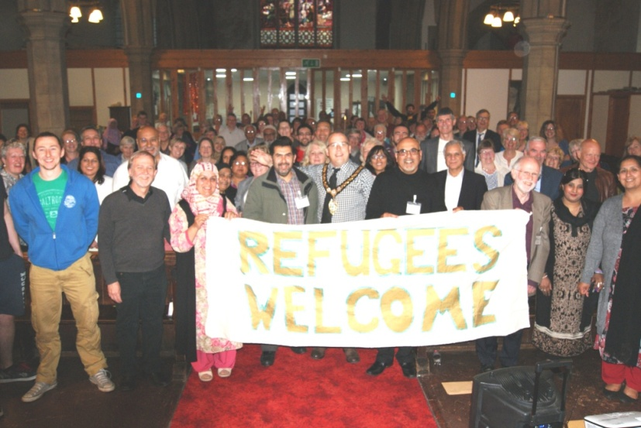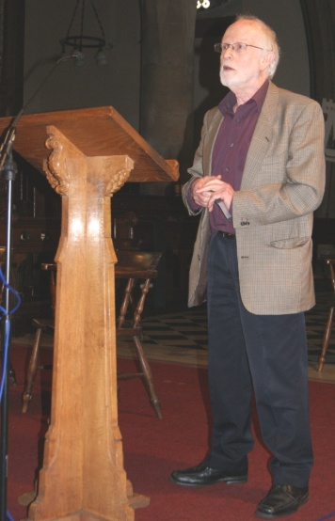
We had a successful Open meeting at St Stephen’s Church in Redditch to publicise and gather support for the new joint towns’ group. Over 400 people have promised support and are on our data base.

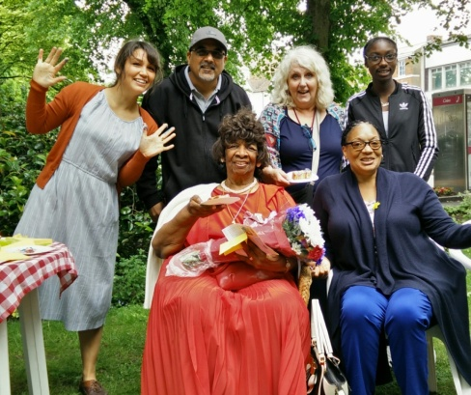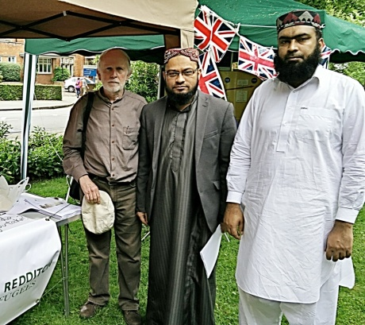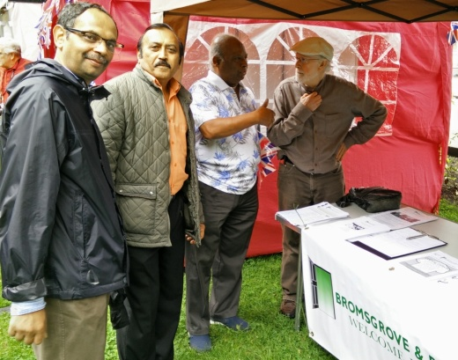
BRWR ran a stall in the Redditch Town bandstand event as part of the Queen’s 90th birthday celebration informing people of the refugee situation and to recruit volunteers. We also publicised the official 'Refugee Week.’

On Monday of Refugee week, four of us gave a PowerPoint presentation at St. John’s C of E Middle School in Bromsgrovefor their RE Enrichment day ‘Who is my Neighbour?’. We were a Christian, a Muslim, a Hindu and an Agnostic, but all demonstrating that we had the same human values and treated each other with tolerance, love and respect.

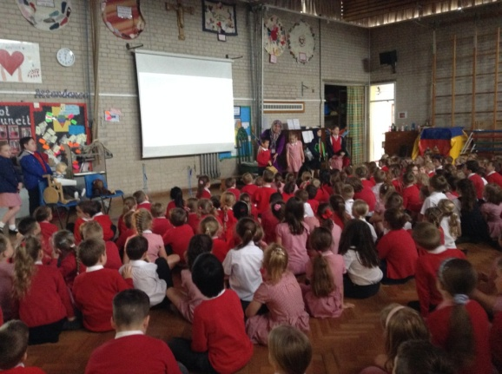

Presentations in school assemblies across Redditch has continued.The schools agreed to raise funds for the refugees by non-uniform days and other means – such as making a globe with pennies.

Some of our volunteers are reading story books about refugees to groups of young children at the public library in Bromsgrove.

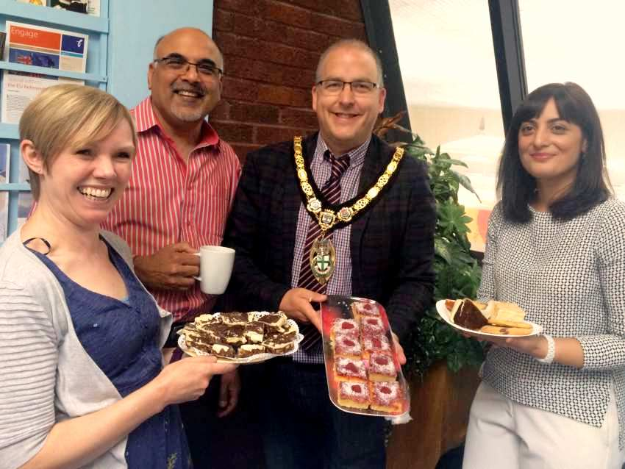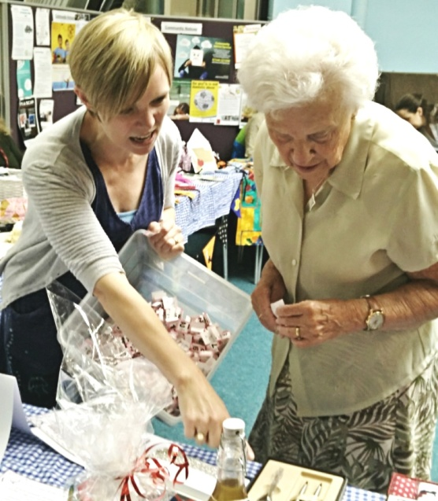

On Tuesday we held a very successful fund-raising coffee morning at the Ecumenical Centre in Redditch. Coffee mornings will continue to be held in different venues,throughout the next few months.

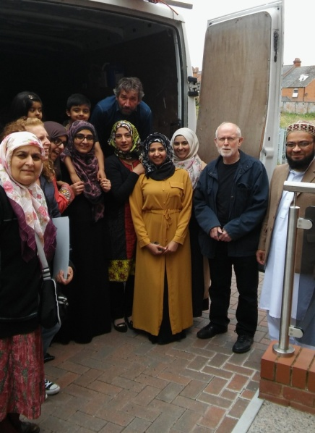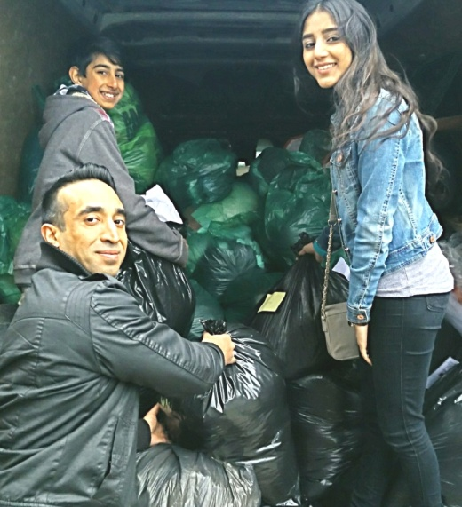

We have been collecting clothes and toiletries for refugees in the camps under the ‘People in Motion’ initiative. In Refugee week the van collected from the Central Mosque and St Luke’s Anglican Church in Redditch. Previous collections from Bromsgrove have filled the van with over 900 bags. The goods are then driven to Malvern by a volunteer, where they are sorted and taken to refugee camps in Europe.

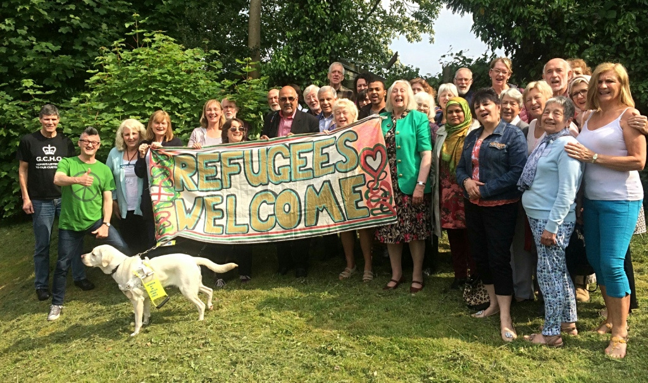

Redditch is expecting 3 families from Syria at the end of this month, under the Vulnerable Persons Relocation Scheme (VPRS) with more expected in July. Bromsgrove will welcome some later in the year.

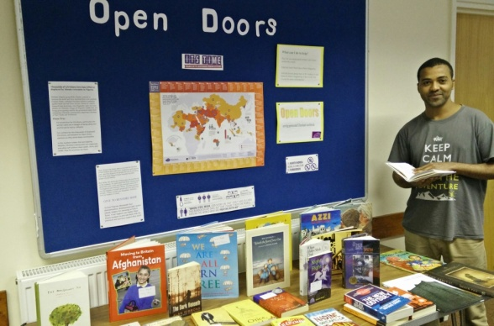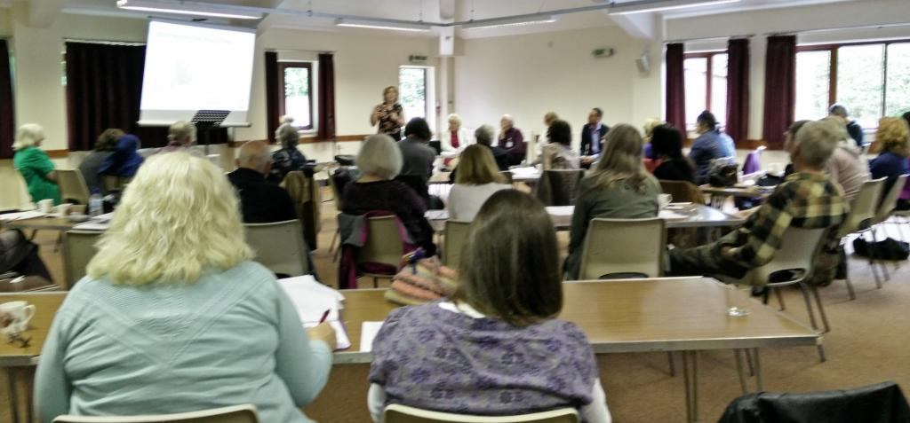

Refugee Action, who have the contract in Worcestershire to settle refugees here, spoke about how the process would be managed, at a recent Training Day which BRWR had arranged for our volunteers. This was attended by 120 people, and the keynote speaker was Professor Jenny Phillimore from Birmingham University talking about successful integration. Our volunteer team leaders ran 3 workshops. One explored the differences in our cultures and also considered Ethics for Interpreters; other workshops were focussed on fund-raising and publicity.

We have a fund-raising dinner organised at Redditch Town Hall, on July 9th, to welcome the refugees. Tickets were on sale in Refugee Week.

