My Pledge

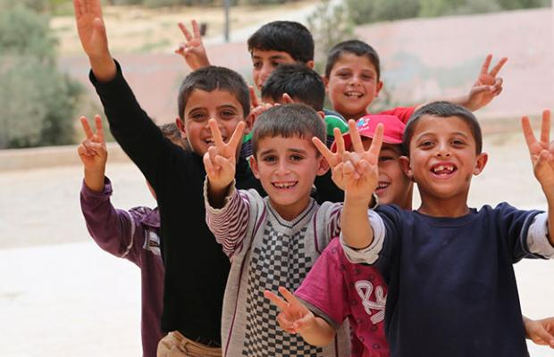

I (name)----------------------------------------- pledge to pay the amount of £--------

as a single gift or a monthly donation of £--------

I will pay this by credit card or cheque made payable to “Bromsgrove and Redditch Welcomes Refugees” to support their work resettling Refugees anywhere in Worcestershire county.

My address is: __________________________________________________________

______________________________________________________________________

My email address is:

My phone number is:
______________________________________________________________________

Signed…………………………………………………………………

Dated………………………………………………………………………

Please scan and email your Pledged form today to naeemarif57@gmail.com or send by post to:
Naeem Arif, 13 Dawson Road, Bromsgrove, B61 7JF
THANK YOU

